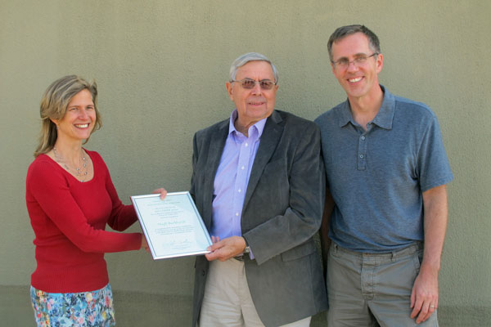 | International Society for Design and Development in Education Selects Winner of Sixth Annual Design Award, “The Eddy”  Hugh Burkhardt from the Shell Center & Nottingham University
The 2013 Prize of $10,000 was for “a substantial body of work, by an individual or a team, over a period of years that shows excellence in design for education in Science or Mathematics”.
On October 9, at the 2013 ISDDE conference in Berkeley, California, the award was announced and the prize presented to Professor Hugh Burkhardt.
For more than 35 years, Hugh Burkhardt has made outstanding contributions to educational design. He has done so through his leadership of the Shell Centre for Mathematical Education, his contributions to a large number of its influential products, and the development of its engineering research methodology. He has fostered the improvement of educational practice through the use of high quality assessment and the creation of institutions that foster excellence in educational design. His initiatives have often involved questioning established orthodoxies in both mathematics education research and design. Impact on learning and teaching in classrooms has been his priority throughout.
Together with his award-winning team at the Shell Centre, Hugh Burkhardt has led over a dozen design projects that are widely recognized for both their quality and their impact on practice. Professor Burkhardt’s various contributions involve strategic design, structural design, technical design, and design approaches and methods.
Strategic design looks beyond the immediate functionality of a design to the wider implications of how people and systems are likely to implement it. Contributions of this type relate to understanding mechanisms such as “What You Test is What You Get” (WYTIWYG) – how high-stakes assessments influence the implementation of the intended curriculum and can either be a barrier to or lever for change. The design technique he developed of changing only 5% of lessons profoundly each year for a few years is easier, cheaper and less disruptive than sudden across-the-board upheavals, yet can yield tremendous long term impact.
Structural design concerns product features that promise power in forwarding the underlying vision and strategy. Professor Burkhardt has introduced new and refined design concepts and models for classroom material and assessment. These include the categorization of tasks as novice, apprentice or expert based on their demand for autonomous thinking, and the integration of teaching material, professional development and assessment into coherent, themed ‘boxes’.
Technical design contributions he has made include “role shifting”, where students are led to take on teacher roles like explainer and task-setter.
Finally, Professor Burkhardt’s leading role in the establishment of ISDDE and the journal Educational Designer represent substantial contributions to advancing the field, and the community of educational designers.
This description presents only highlights from the overall case that was made in nominating Hugh Burkhardt for the lifetime achievement in educational design. In consideration of Prof. Burkhardt’s association with ISDDE, an independent panel was asked to make the final selection from the shortlist. The prize committee and recipient welcome inquiries.

About the International Society for Design and Development in Education
ISDDE was founded to bring together outstanding designers and developers to collectively define and achieve excellence in educational products and materials, particularly for science, math, and technology; and to create a professional community that shares knowledge, research, approaches, and critiques. ISDDE advances these goals through annual conferences, an e-journal, Educational Designer, and “The Eddies,” which recognize and give exposure to outstanding work in the field. For more information about ISDDE and its awards, visit www.isdde.org.

Contacts:
- Christian Schunn, Chair, ISDDE Prize Committee, +1 (412) 624-8807 schunn@pitt.edu
- Hugh Burkhardt, +44 (115) 951-4411 hugh.burkhardt@nottingham.ac.uk

